Water Purification
- Large-Scale Purification:
  - Process:
    - Conducted by water treatment plants.
    - Involves filtration, disinfection, and chemical treatment.
  - Objective:
    - Provide clean water to a large population.
    - Ensure water meets quality standards for consumption.
  - Advantages:
    - Treats water from natural sources like rivers or reservoirs.
    - Ensures water is safe for consumption by homes, schools, and businesses.
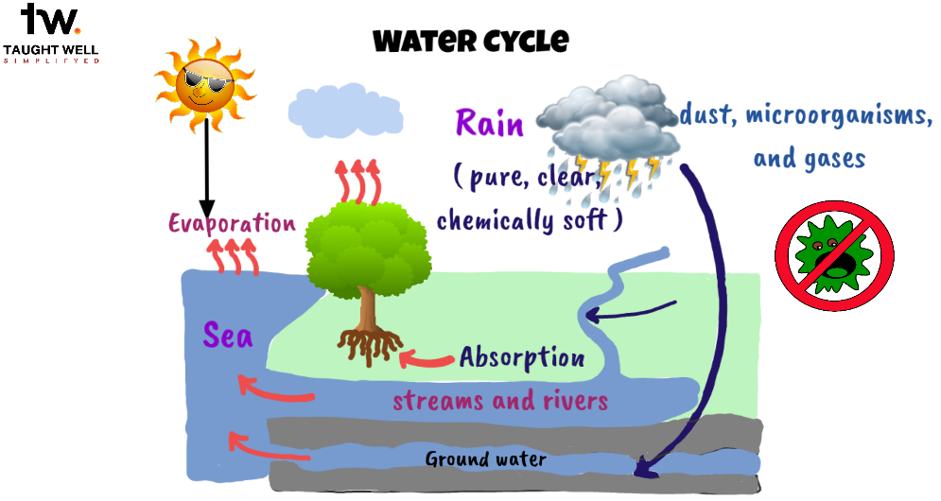
- Small-Scale Purification:
  - Methods:
    - Boiling, chemical disinfection, and filtration.
  - Purpose:
    - Treat water at a smaller level, often for individual households or communities.
    - Remove contaminants and ensure safe drinking water.
  - Advantages:
    - Suitable for areas with limited access to large-scale purification facilities.
    - Simple and effective methods for household use.
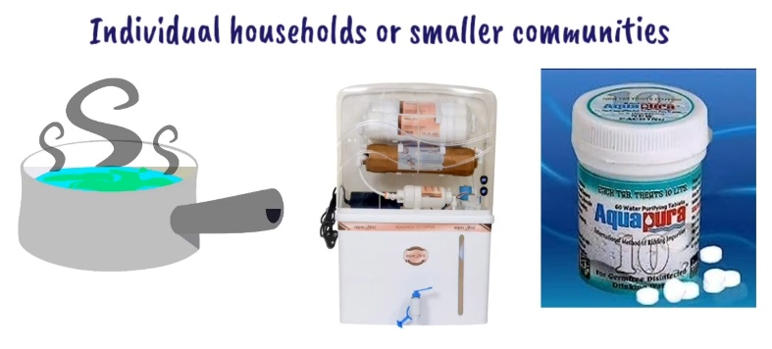
Household Purification Methods:
- Boiling:
  - Bring water to a rolling boil for one minute to kill harmful bacteria and pathogens.
  - Simple and reliable method for ensuring safe drinking water.
- Chemical Disinfection:
  - Use substances like bleaching powder, chlorine solution, or chlorine tablets.
  - Follow recommended amounts and contact time for effective disinfection.
  - Kills pathogens and makes water safe for consumption.
- Filtration:
  - Use water filters with fine mesh or activated carbon to physically remove impurities.
  - Choose reliable filters suitable for bacterial removal and ensure proper maintenance.
Double Pot Method:
- Description:
  - Involves using two cylindrical pots, one placed inside the other.
  - Outer pot: Height of 30 cm, diameter of 25 cm, with a hole positioned 4 cm above the bottom.
  - Inner pot filled with a mixture of bleaching powder and coarse sand.
  - Placed inside the outer pot, sealed with polythene foil.
- Procedure:
  - Lowered into a well using a rope, ensuring immersion at least 1 meter below the water level.
  - Effective for about 2-3 weeks in a well containing approximately 4500 liters of water.
  - Provides a simple and practical method for water purification in communities.
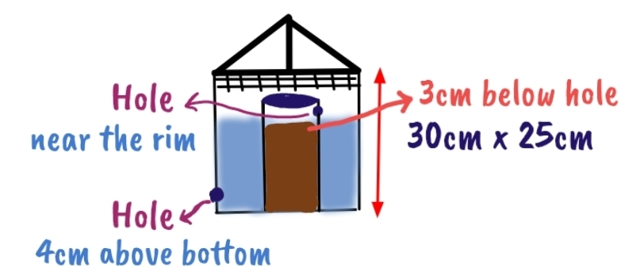
Water Purification on a Large Scale:
- Storage:
  - Water drawn from sources and stored in reservoirs.
  - Acts as a reserve, protecting water from pollution.
  - Natural purification occurs during storage:
    - Physical: Suspended impurities settle due to gravity.
    - Chemical: Changes like ammonia decrease, nitrates increase.
  - Bacterial count decreases over time, enhancing safety.
  - Proper maintenance crucial to prevent algae growth.
- Filtration:
  - Slow Sand Filters:
    - Consist of supernatant water, sand bed, and biological layer.
    - Allows partial purification through sedimentation, adsorption, and bacterial action.
    - Simple construction, lower cost, and high-quality filtered water.
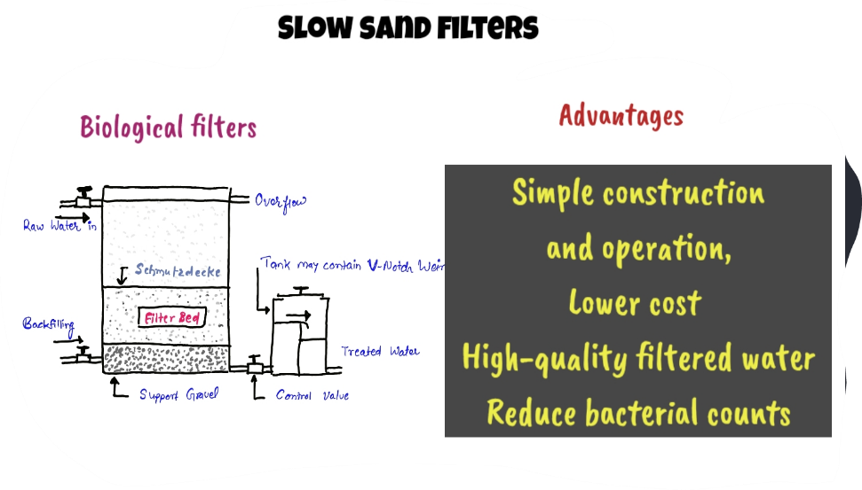
  - Rapid Sand Filters:
    - Types: gravity and pressure filters.
    - Process involves chemical coagulation, flocculation, sedimentation, and rapid sand filtration.
    - Requires backwashing to maintain efficiency:
      - Reverses water flow to dislodge accumulated impurities.
      - Frequent washing needed, typically daily or weekly.
    - Advantages: Handles raw water directly, higher filtration rate, occupies less space, and offers flexibility in operation.
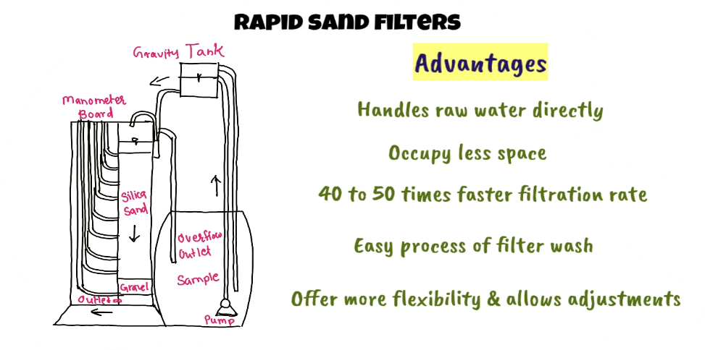
- Chlorination:
  - Works alongside filtration to kill pathogenic bacteria.
  - Forms hydrochloric and hydrochlorous acids in water.
  - Hypochlorous acid primarily responsible for disinfection.
  - Methods:
    - Chlorine gas: Affordable, efficient, requires specialized equipment.
    - Chloramines: Less chlorinous taste, slower action, less commonly used.
    - Perchloron or HTH: Calcium compound, high chlorine content, used for disinfection.
  - Break point chlorination: Chlorine dose increase leading to residual chlorine increase until a saturation point is reached.
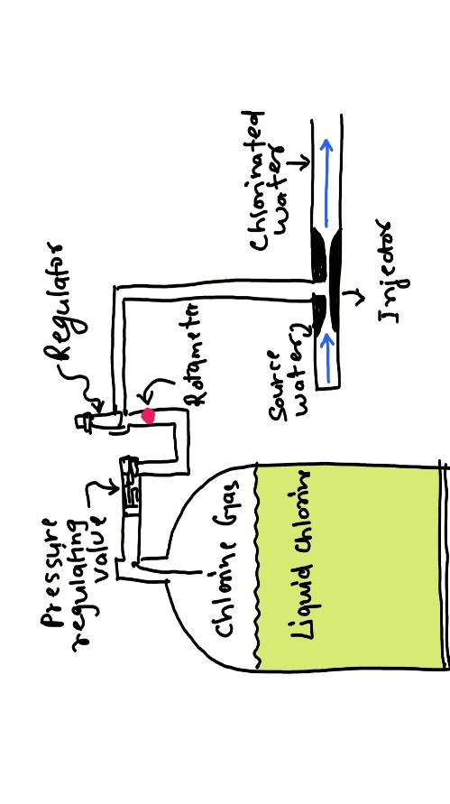
Large-scale water purification involves storage, filtration, and chlorination, ensuring water safety and quality for consumption on a broad scale. Proper implementation and maintenance of these methods are essential for providing clean water to communities.

